Kelly’s Bay

https://maps.app.goo.gl/py66bhbRvgFLsweM9?g_st=ic

Parking
Northcliffe Heights Rd (Main Rd)
Parking spaces available above and below entrance to Kelly’s Bay (Do not park on Cycle Lane below entrance)

Do Not Park in Estate or block residents please.

https://maps.app.goo.gl/eXdfb2zWJuzRWPRd6?g_st=ic

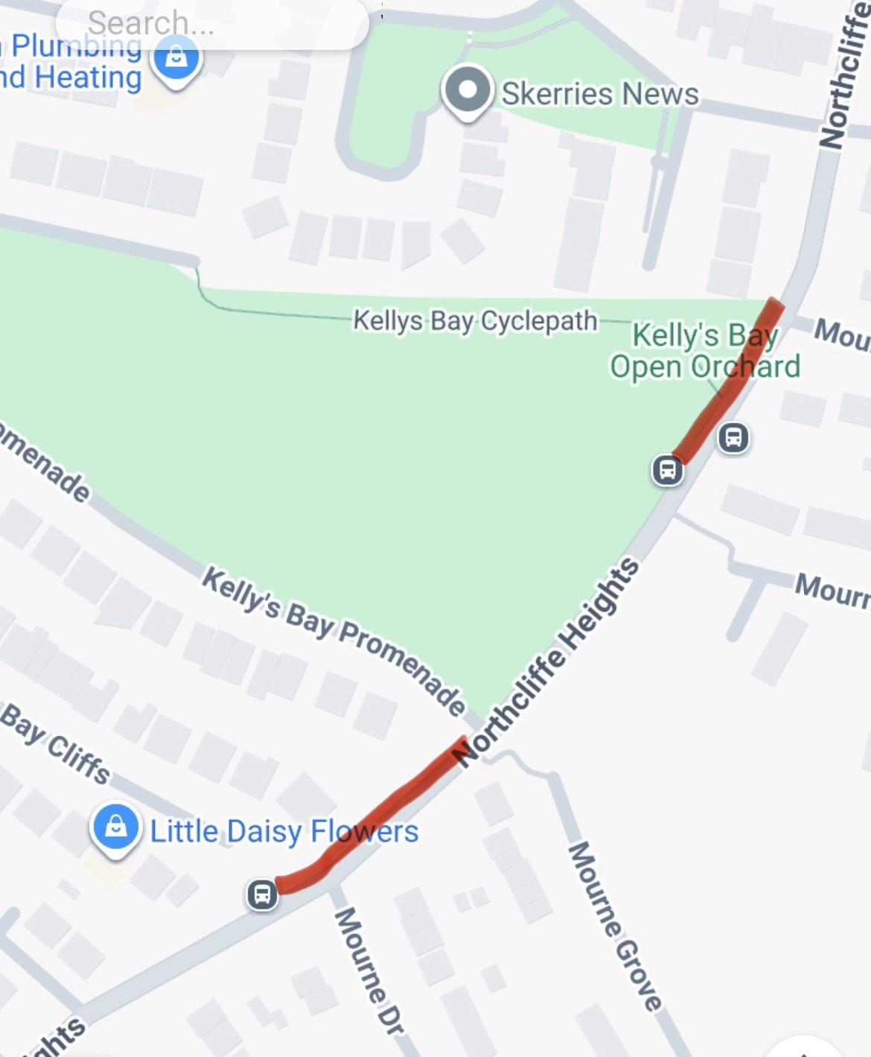

Toilets
Unfortunately none available at Pitch
Use Harps Club House or Community Centre.

